009 Gulp - choosing a plugin

Gulp Kata List – Blog Page

[Gulp Kata List on GitHub](https://github.com/robertdunaway/katas-gulp)

# Duration

5 minutes

# Brief

Refining our process for choosing npm plugins.

### For More Information

BING/GOOGLE: “Gulp npm plugin”

Book: <http://www.amazon.com/Gulp-Quick-guide-getting-running/dp/151468960X>

# Instructions

Get tutorial folder or the entire katas-angular2 repo.

Open the [before/*.sln] file and execute the kata.

Feel free to execute this kata multiple times because repetition creates motor memory.

# Github

* https://github.com/robertdunaway/katas-gulp/tree/master/009%20Gulp%20-%20choosing%20a%20plugin

# Kata

Choosing the best plugin is a simple matter of discovering the popularity of competing plugins and checking the plugins Github repo.

Checking the popularity of competing components.

Go to <https://www.npmjs.com>

In the search box enter, “gulp rename”. We are looking for a plugin for renaming files.

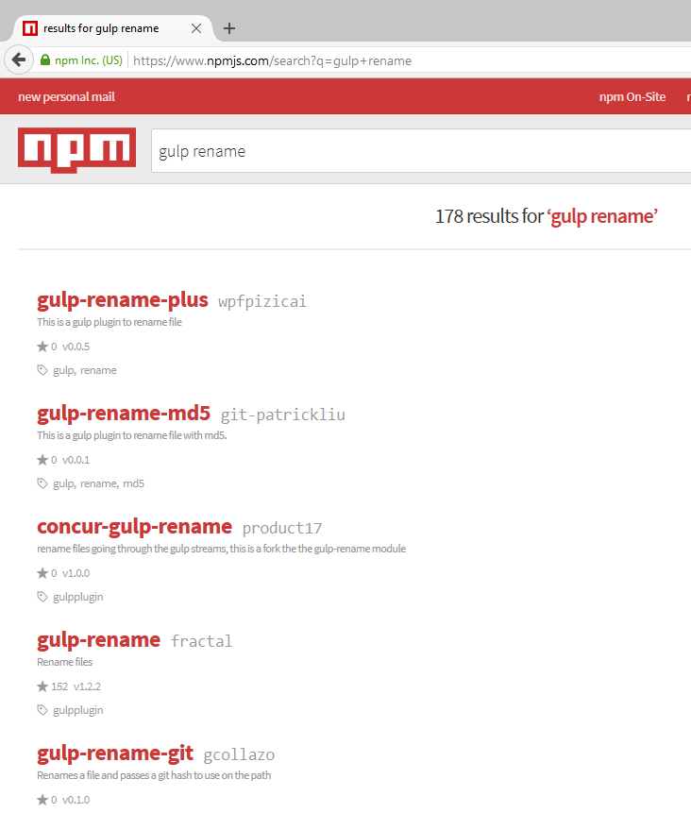

Opening each plugin you will see how popular the plugin is by virtue of the number of downloads. You can also read the “Usage” section to get an idea of the plugins intent.

gulp-rename-plus

* 0 downloads in the last day

concur-gulp-rename

* 0 downloads in the last day

gulp-rename-git

* 0 downloads in the last day

gulp-rename

* 41,362 downloads in the last day

In this case it seems obvious which plugin is getting attention and is probably well supported with an active community.

There are a few things to look for in Github.

**Velocity of commits**

This is an indicator of activity and interest in the plugin. If no commits have been performed in a year or two, then I’d consider another plugin. The one exception is if the plugin does a very specific task and has simply matured and, essentially, complete.

Most code is never complete but it does happen.

**Number of open issues**

If there are no commits but many open issues, then that’s an indicator the plugin has been abandoned.

In this case the latest code was updated 5 months ago. There are 5 issues but none seem serious. This is probably a safe plugin to use.

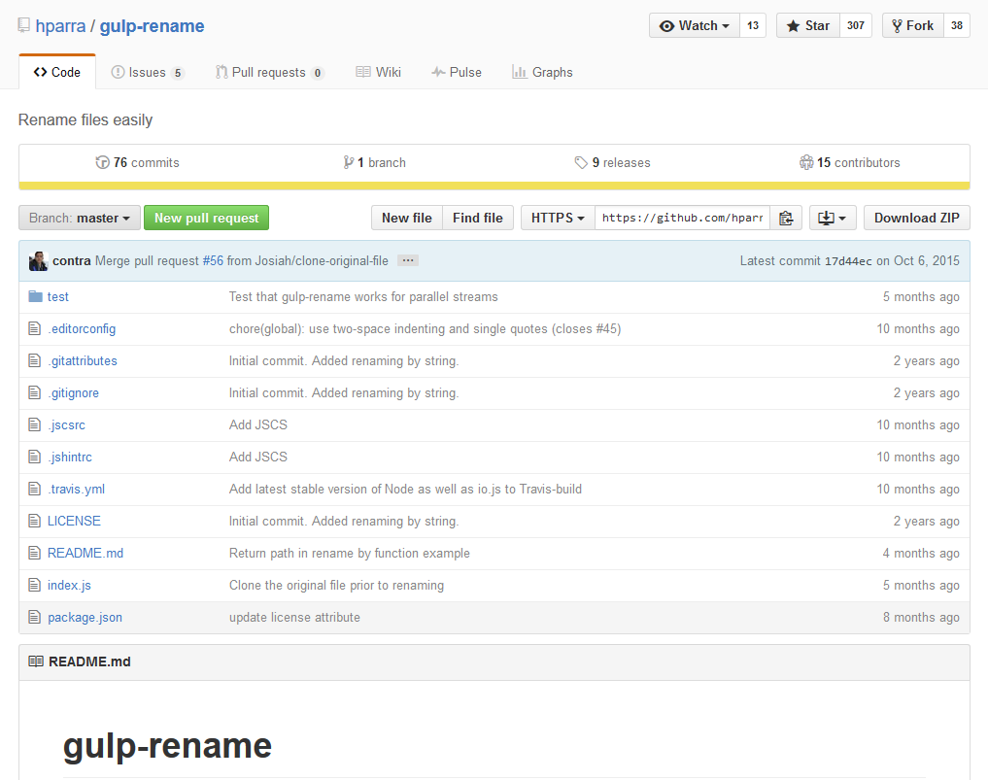

You might consider that you don’t have to worry about a components popularity or activity when published by Microsoft, Apple, or IBM. You would be wrong. You simply don’t have the visibility into corporate products that you have with open source.

# Next

Take a few minutes and imagine more examples.